Oliver Copp
media@tnmte.com FOR IMMEDIATE RELEASE: 6/29/2020

PC Wrestling Simulator Legend TNM Returns
With “TNM Tournament Edition”
Watch crazy pro wrestling tournaments unfold and follow along with the play-by-play,
round for round, match for match, move for move - tap, nap, or snap
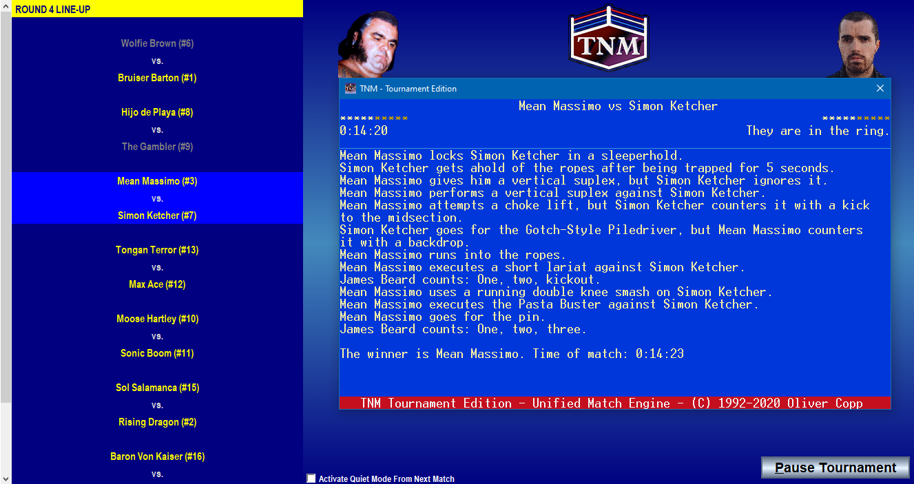

Landshut, Germany – June 29, 2020 – German game creator and longtime sportscaster Oliver Copp today announced the release of his new pro wrestling simulator TNM Tournament Edition to commemorate the 25th Anniversary of the long-running TNM simulator series on July 1. The new simulator focuses on running different kinds of user-determined tournaments and generating the play-by-play for each tournament match, combining an easier, more casual gameplay experience than series stalwart TNM 7 Second Edition with a sleek graphical interface and pro wrestling’s only match simulation engine.
Quickly becoming the most popular wrestling simulator in the early years of the World Wide Web, the TNM series has reached players in 87 countries to date. “For many years, I was frequently asked when a Windows-based version of TNM was coming as it was getting more and more difficult to use DOS-based applications”, explains Copp. “That time is now. Most wrestling simulators on the market, even today, focus on the minutiae of running wrestling promotions – negotiating contracts, keeping track of their roster and many other related things. TNM has always focused on the actual simulation of matches and creating engagement through stimulating the user’s imagination rather than forcing them to carry out a list of tasks every day.”
The TNM series’ play-by-play engine simulates matches move-by-move and lets the player read along while the action is unfolding. Players can create different types of tournaments from Elimination Tournaments to Round Robin Tournaments to a new tournament type popular in the eSports community, Swiss-Rules Tournaments. Users may award different point values for different types of wins and losses. They may choose to carry out single-phase tournaments or dual-phase tournaments where block winners of the first phase advance to a second phase which determines an overall winner. Or, if they are in a trolling mood, they can switch things up and have losers advance to find out who the overall tournament turkey is.
Every tournament run influences TNM Tournament Edition’s global rankings. Competitors are seeded going into tournaments and are awarded points for their progress, overachieving in either individual matches or the tournament itself compared to how they were expected to do and a dozen other factors. Users are able to change ranking criteria on the fly and apply them going forward as well as retroactively to ensure the rankings reflect what is important to the user, not the developer.
It’s time to put on those spandex trunks and get back in the ring. Download your free four-week trial version now at tnmte.com.
###
About Oliver Copp
Oliver Copp is a sportscaster and independent game developer based out of Landshut, Germany. Copp first created what would later evolve into the pro wrestling simulator TNM while in university in the early 1990s and has kept releasing new versions and expansions ever since.
In his 23-year-career as a sportscaster, Copp has lent his distinctive voice to thousands of hours of programming for brands such as All Elite Wrestling, the Ultimate Fighting Championship, World Championship Wrestling, Extreme Championship Wrestling, and the Stihl Timbersports Series.
More Information
For more information on TNM Tournament Edition, please refer to our Media Pack at tnmte.com/media. Review copies are available by e-mailing media@tnmte.com.
For more information on TNM 7 Second Edition, please head over to tnm7.com.
Contact
Inquiries Twitter Facebook Web
media@tnmte.com twitter.com/tnm7sim facebook.com/tnm7sim tnmte.com

